Q84 From Q83
============
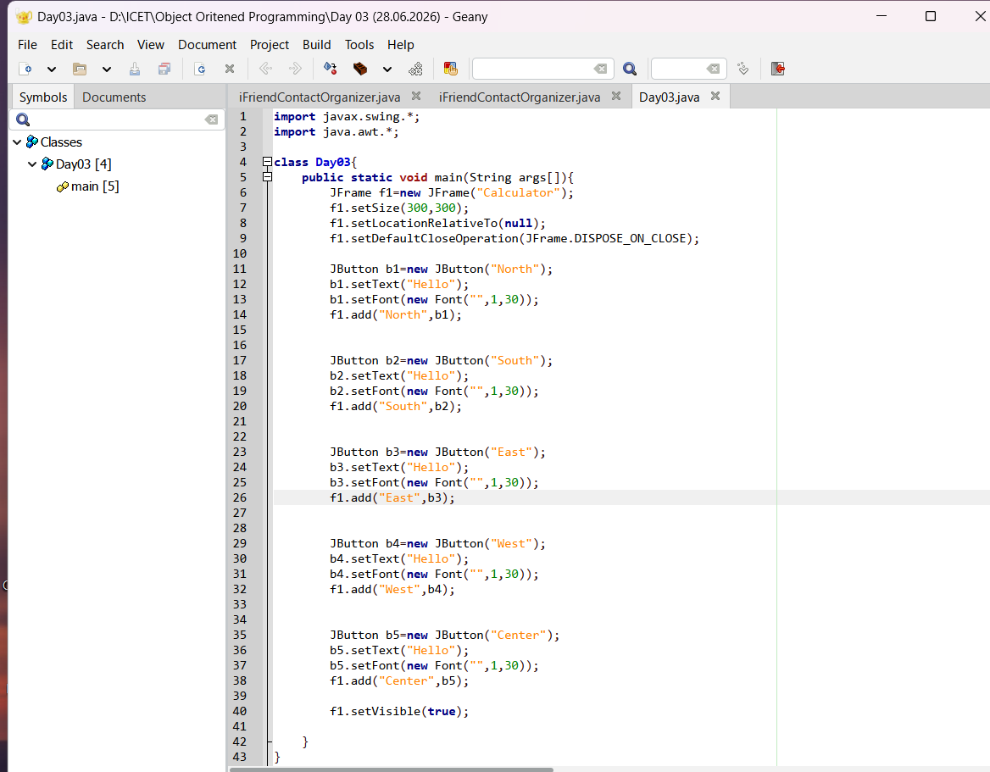

Q87
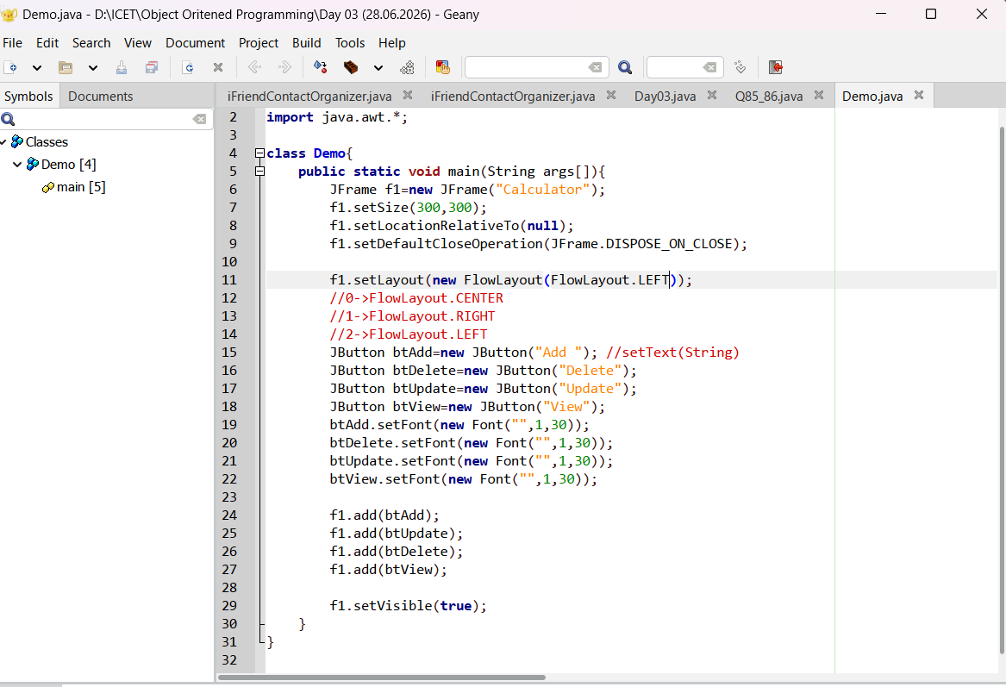

Q91 Exercise
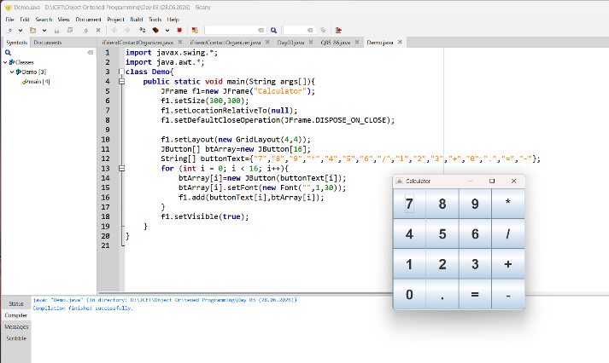
===========

Q100 From Q99 Using Inheritance
============================
//Calculator ->Subclass
//JFrame -->Super class

